Creating From The soul
HOW TO MANIFEST FROM YOUR SOUL
Using your soul and higher self to manifest what you want.
Cheryl Glover, Author of the book “Creating From The Soul” will facilitate a workshop based on her book‘s tools and methods to raise consciousness and manifest from higher consciousness.
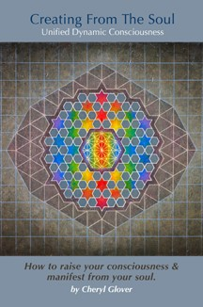
“Creating From The Soul” is a journey into the mind and spirit. Through these pages, you will delve into the depths of your soul and find its path to God. The book illustrates ways to open your insights, remove your psychological and spiritual blocks, guiding you to higher consciousness, creating more harmony, and improving your life. We include methods and philosophies from Kabbalah, New Thought, Pathwork Center, and other insights.

Raise your consciousness as you explore messages from the Prophet Elijah, who will lead you to the higher levels of your soul to find wisdom and understanding.

Official book website: http://www.creatingfromthesoul.com

Cheryl Glover is a spiritual teacher, Kabbalist, spiritual counselor, healer, Reiki Master, author, gifted channel and psychic. A gifted speaker and teacher she has taught classes on spirituality for twenty years. Her popular website: http://www.newthoughtkabbalah.com runs a free spiritual wisdom newsletter.

